1. Before understanding the **Spring IoC Container**, let’s understand the **Tightly Coupling and Loose Coupling**.
2. 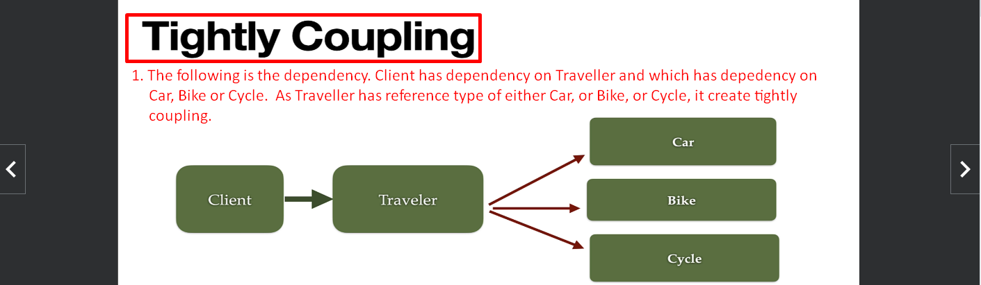
3. 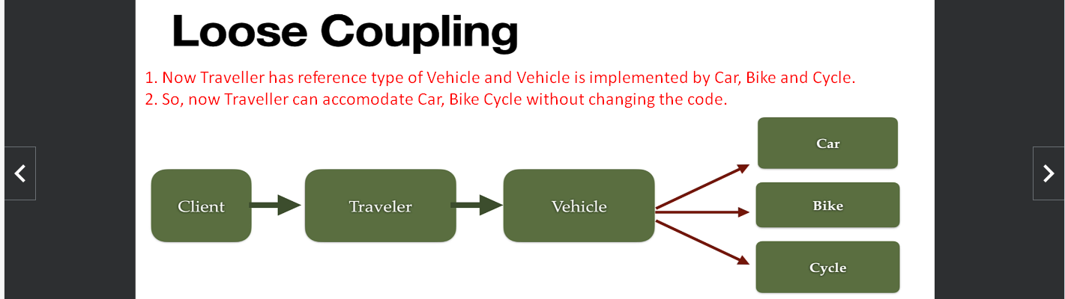
4. To achieve loose coupling, we can use Java Interface or Abstract Class as we are doing above.
5. 